**SELECT Statement Problem 4**

4) List the plan number, line number, resource name, number of resources ( eventplanline.number ), location name, time start, and time end where the event is held at the basketball arena, the event plan has activity of activity of “Operation”, and the event plan has a work date in the period October 1 to December 31, 2018. Your query must not use the facility number (“F101”) of the basketball arena in the WHERE clause. Instead, you should use a condition on the FacName column for the value of “Basketball arena”.

A) ***Syntax of SELECT Statement :***

SELECT * FROM TABLE_NAME;

**SELECT** EventPlanLine.PlanNo,LineNo,ResName,NumberFld,LocName,TimeStart,TimeEnd

**FROM** EventPlanLine,ResourceTbl,Location,Facility,EventPlan

**WHERE**(EventPlanLine.ResNo=ResourceTbl.ResNo)

**AND**(EventPlanLine.LocNo=Location.LocNo)

**AND**(EventPlanLine.PlanNo=EventPlan.PlanNo)

**AND**(Location.FacNo=Facility.FacNo)

**AND**(FacName='Basketball Arena')

**AND**(Activity='Operation')

**AND**(WorkDate **BETWEEN** '01-Oct-2018' AND '31-Dec-2018');

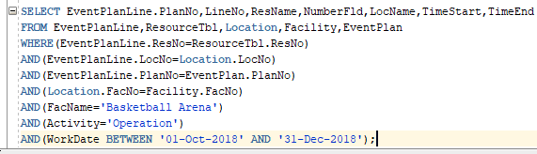

***Output :***

